23.91: a)

b) 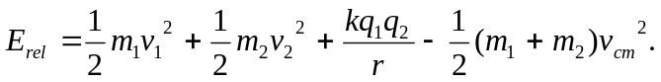
After expanding the center of mass velocity and collecting like terms:
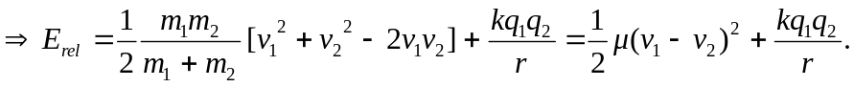
c)
d) Since the energy is less than zero, the system is “bound.”
e) The maximum separation is when the velocity is zero:
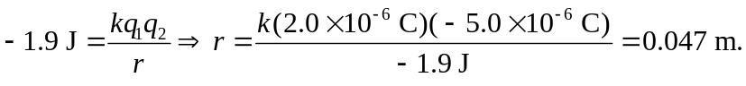
f) Now using
